GDPR, Ethics, and Potential Impact

Alzheimer’s Detection with Convolutional Neural Networks – Minor Artificial Intelligence for Society

Sverre van Gompel  
19-10-2021

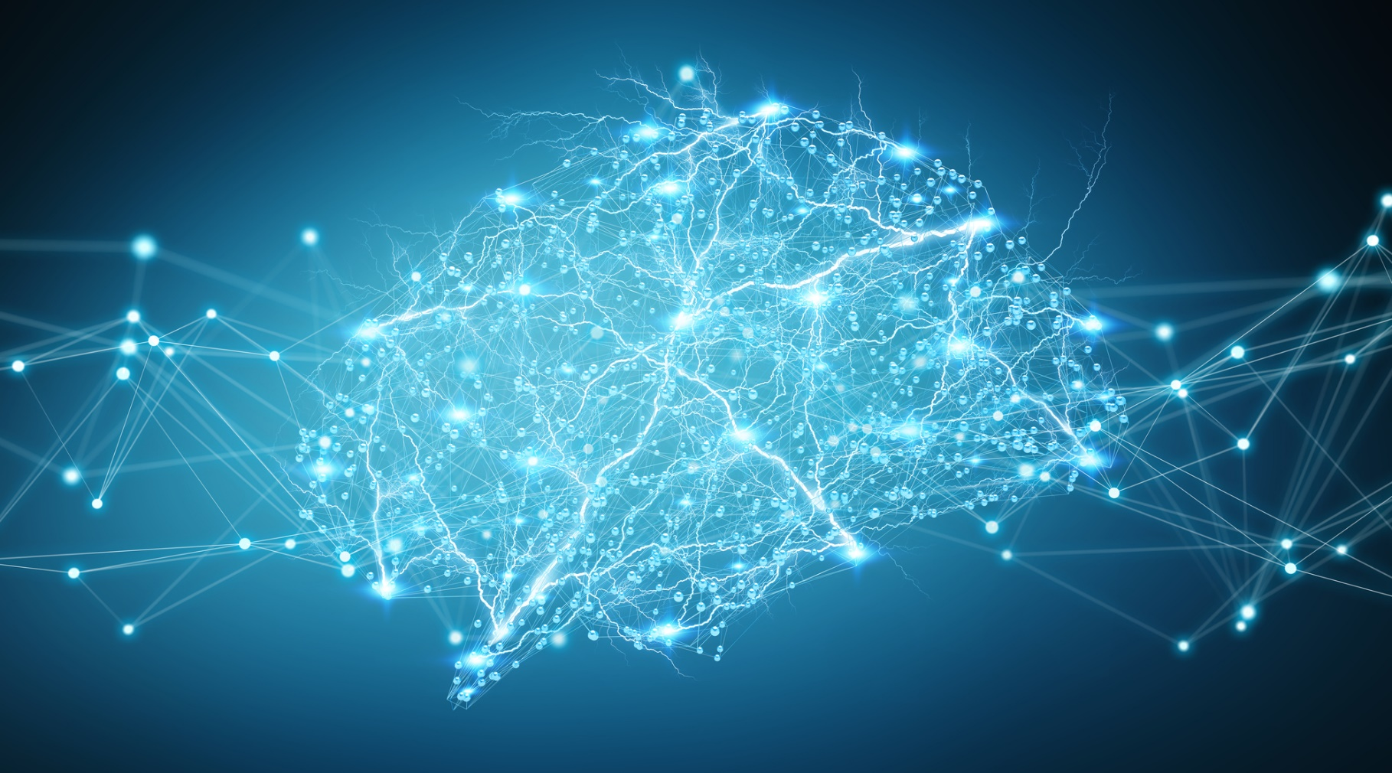

# Introduction

The medical field is currently experiencing an AI revolution. Many hospitals are conducting their own research on implementing artificial intelligence solutions within their processes. For example, [ETZ in Tilburg recently applied AI to detect fractures on x-ray photo’s](https://www.etz.nl/Over-ETZ/Nieuws/2021/09/AI-toepassing-ziet-breuken). AI has the potential to provide substantial improvements to existing processes within the medical field, as well as the possibility to innovate new solutions.

A possible use case for AI is assisting radiologists in the diagnostic process. An AI could analyse scans and highlight any irregularities it detects. By combining the expertise of radiologists with an AI, misdiagnoses could potentially be prevented, and Alzheimer’s disease could be detected earlier, improving overall outcomes for patients. This leads to the following question:

How can neural networks be used to detect various stages of Alzheimer’s disease?

# Contents

Introduction 2

Contents 2